Unearthing the Environmental Impact of Human Activity: A Global Co2 Emission Analysis

 Project submitted to the 

**Project Based Experimental learning Naan Mudhalvan-Smart internz**

**Submitted by**

**(Team ID: NM2023TMID28526)**

**Team size:4**

**Team Leader: S. JAYACHITHRA**

**Team member: V. ROHINI**

**Team member: E. MEENA**

**Team member: M. MEENA**

Under the Supervision and guidance of

**Dr.E.DEVANESAN,M.Sc.,M.Phil.,B.Ed.,PhD**

**UG DEPARTMENT OF PHYSICS**

**DHIVYA ARTS AND SCIENCE COLLEGE**

**CHETPET-606 801**

**2023**

**UNEARTHING THE ENVIROMENTAL IMPACT OF**

**HUMAN ACTIVITY: A GLOBAL CO2 EMISSION**

**ANALYSIS**

# 1.1 OVERVIEW

Global warming is one of the biggest challenges currently being faced by humans, although correlation is not causation, a likely cause of global warming is due to increased atmospheric carbon dioxide from human activities. CO2 emission refers to the carbon dioxide emitted throughout the world. For this analysis we will be focusing on CO2 emissions and its effect on the world we a live in as well as some key factors and stats that may play a role in the emission of CO2 globally. Fossil fuel use is the primary source of CO2.The data throws light onto how much fossil fuels are burnt, per year per nation, which amounts to an increase in CO2 every year. This will help researchers and environment experts to predict global warming, so countries should set a goal to decrease this amount yearly.

Analysing global CO2 emission across counties from 1975 to 2020. This dataset contains a record of CO2 emission by each country and region of earth, here we are going to analyse and visualise country wise, region wise and overall Co2 emission on earth.

# 1.2 PURPOSE

The number of unique visualizations that can be created with a given dataset. Some common types of visualizations that can be used to analyse the CO2 emission include bar charts, tree map, scatter plots, pie charts, maps etc., These visualizations can be used to compare performance, track changes over time, show emission, and relationship between variables, breakdown of factors and emission by countries and continents.

To understand total world emission, Co2 emission over time, total emission by continents.

The business requirements for analysing the Co2 emission globally over time, identifying affecting factors, creating interactive dashboards and reports, identifying areas for improvement, making data – driven decisions, comparing to countries average and creating forecasting models for future performance.

A literature survey is a method of researching existing literature and studies related to a specific topic. In the context of analysing the global Co2 emission, a literature survey would involve reviewing studies and articles that have been published on the topic of emission, as well as studies specific to Co2. The literature survey would include sources such as academic journals, industry reports, and online articles.

By conducting analysis, the countries can identify areas for improvement and take steps to reduce factors that are responsible for Cos emission for environmental sustainability by improving the efficiency and transitioning to low carbon alternatives.

# PROBLEM DEFINITION &DESIGN THINKING

## 2.1 EMPATHY MAP

An empathy map is a template that organizes a user’s behaviour and feelings to create a sense of empathy between the user and the team. The empathy map represents a principal user and helps teams better understand their motivations, concerns and user experience.

An empathy map helps to map what a design team knows about the potential audience. This tool helps to understand the reason behind some actions a user takes deeply. This tool helps build empathy towards users and helps design teams shift focus from the product to the users who are going to use the product. Empathy maps could vary in forms, but they have common core elements. Other than the four traditional categories mentioned above, empathy map could also include other categories. Here are two other categories commonly used:

* **See** category contains information users observed through eyes. It could be what users see in the marketplace or in the immediate environment, other people's saying and doing, or the content they watch or read.
* **Hear** category is what user hears and how that impacts the user. It could be personal connections as well as other recourses such as media. Instead of documenting superficial information streams, team should focus on details that influence the user.

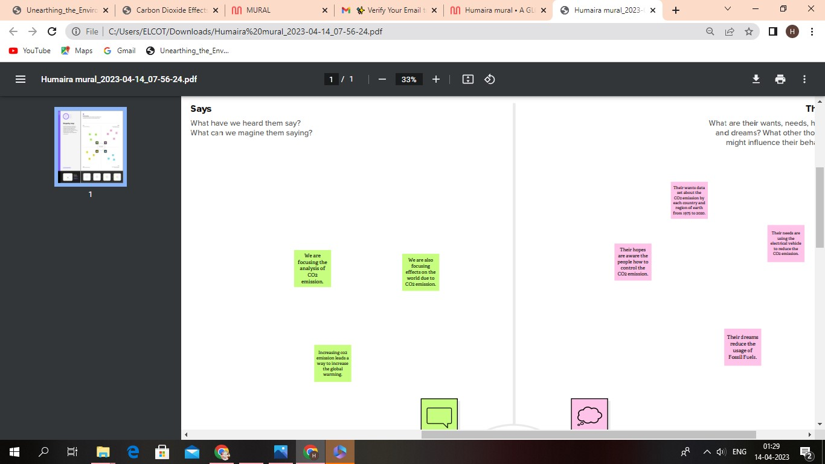

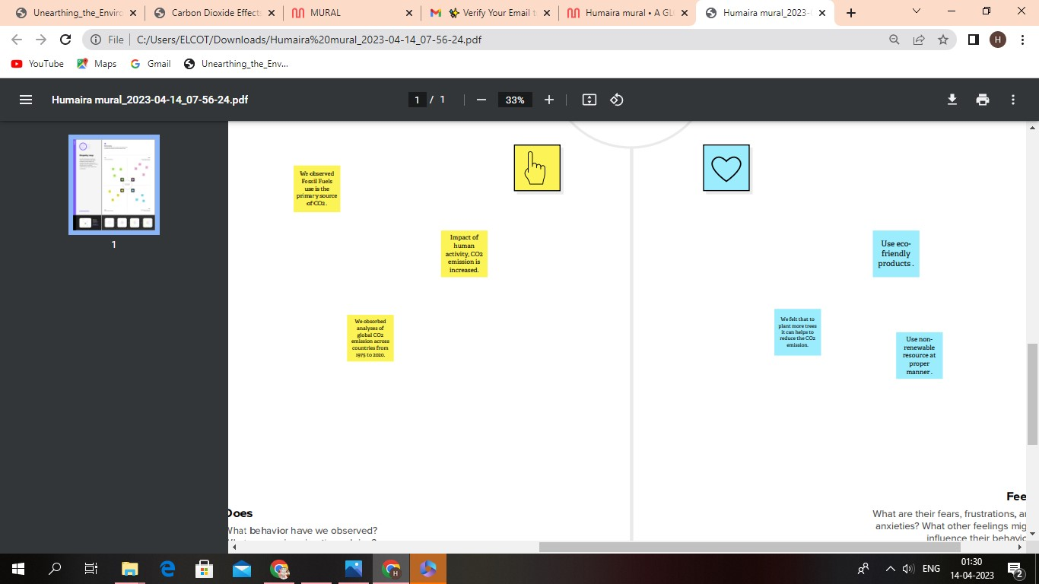

## 2.1 BRAIN STORMING MAP

Brainstorming is a group creativity technique by which efforts are made to find a conclusion for a specific problem by gathering a list of ideas spontaneously contributed by its members. It is a situation where a group of people meet to generate new ideas and solutions around a specific domain of interest by removing inhibitions. People can think more freely, and they suggest as many spontaneous new ideas as possible. All the ideas are noted down without criticism and after the brainstorming session ideas are evaluated.

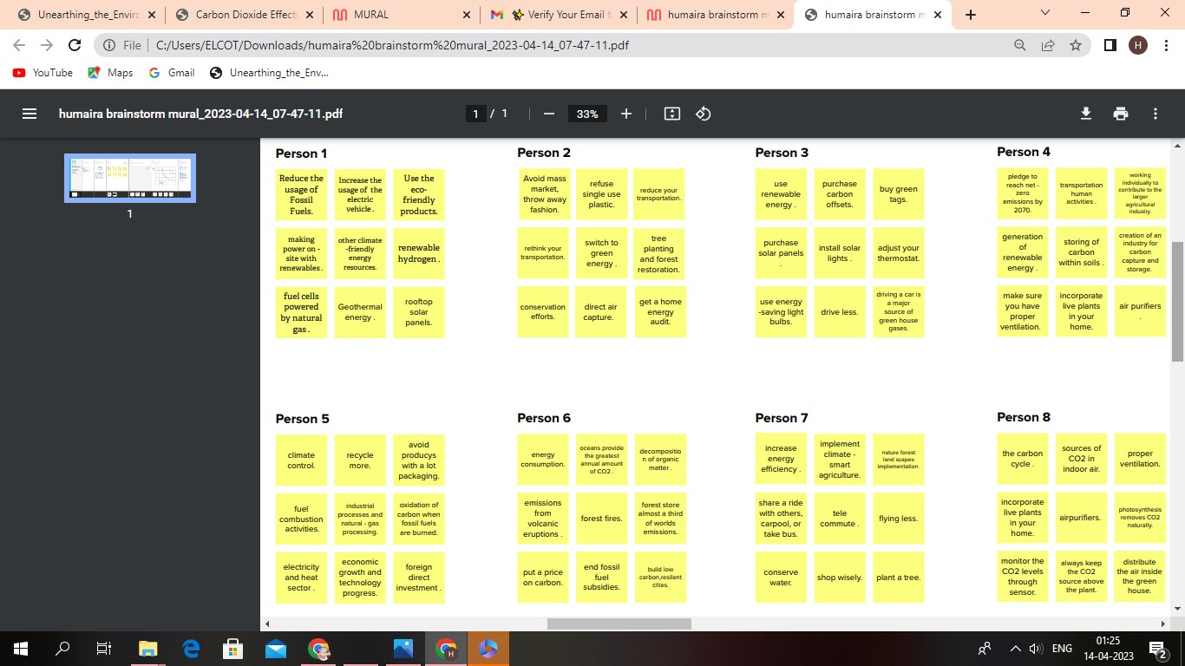

## 3. RESULT

By doing the empathy map and the brainstorming, we get an idea about the theme of the given topic. With the help of those maps, the graph is plotted which depicts the different forms of accurate emission of co2 in the world. It is the map depicting the emission of co2 gas in the entire country. The rate of emission is labelled besides the country.

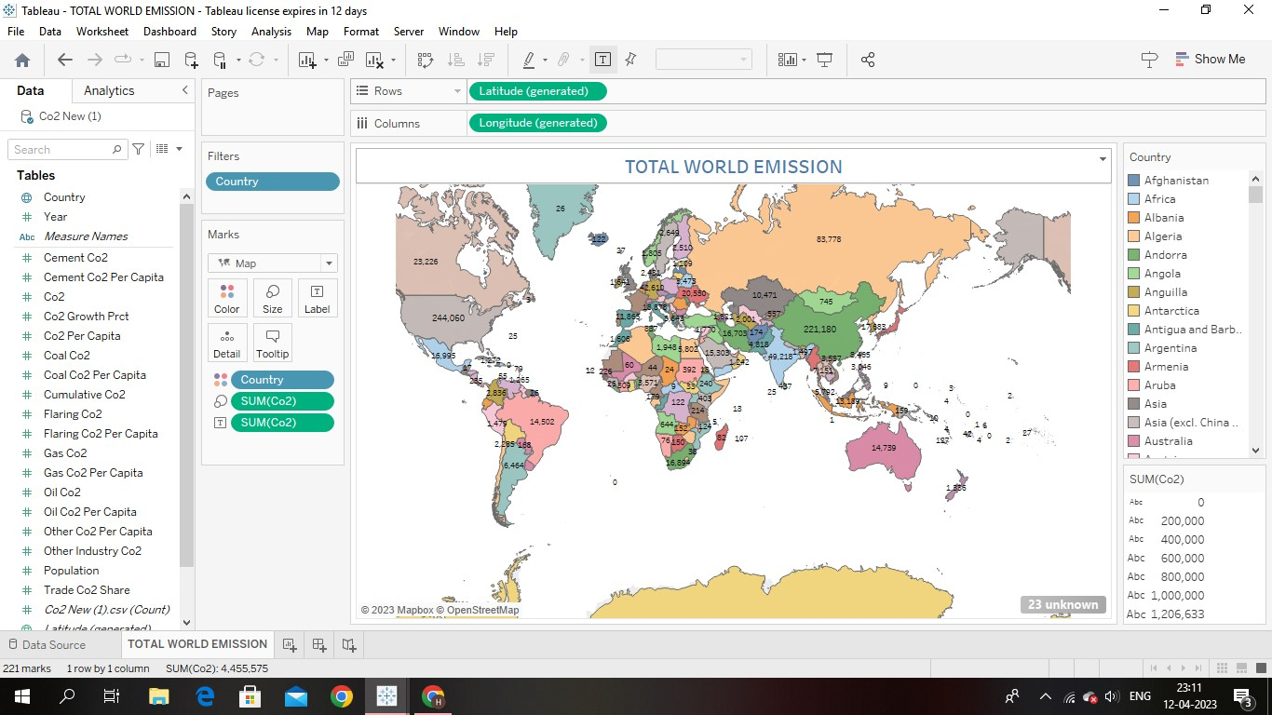

.

It is the map depicting the emission of co2 gas in the entire country.

The rate of emission is labelled besides the country.

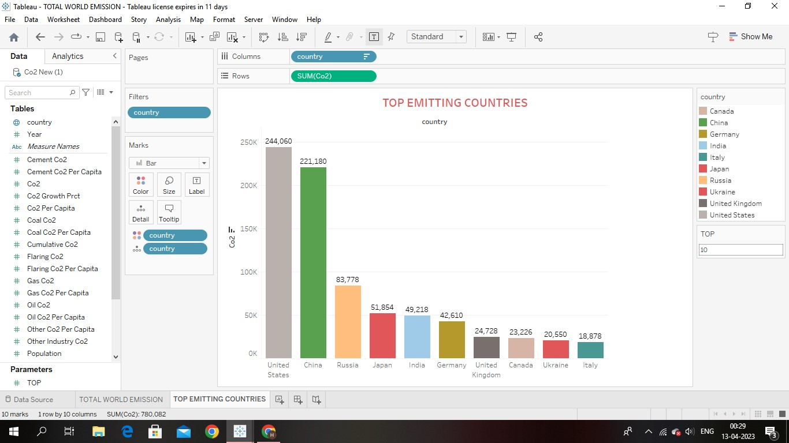

It is the bar diagram which depicts the emission of co2 in the top countries .it indicates that the top 10 countries which occupies first 10 positions in the emission of co2 gas.

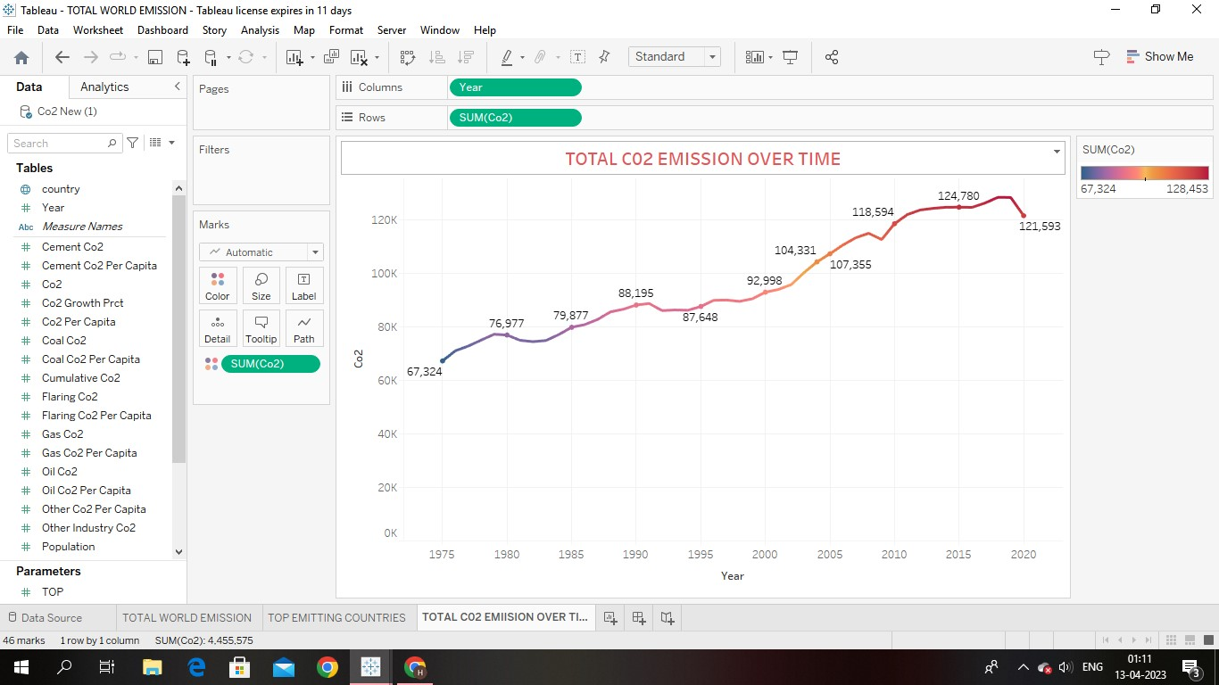

It is the graph which plots the emission is co2 according to years. The emission of co2 rapidly increases from year to year.

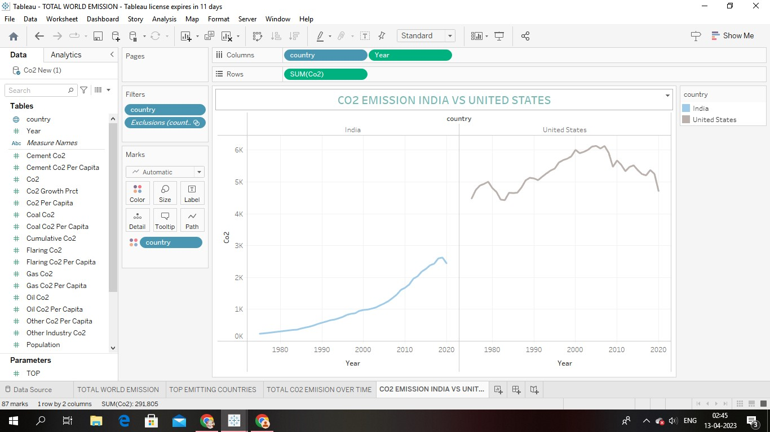

It is the graph mainly plotted to exhibit the comparison between the United States and the India in the emission of co2 gas.

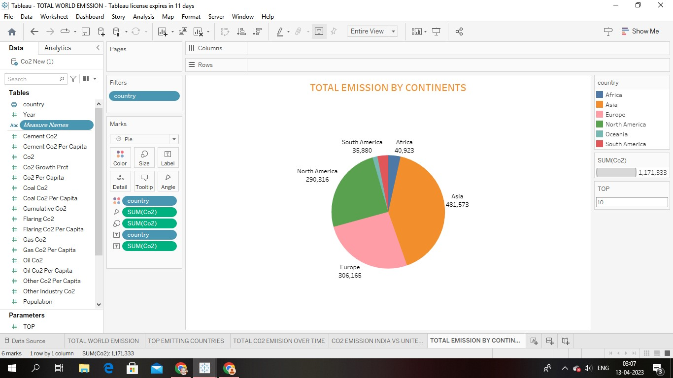

The pie chart diagram represents the total emission of co2 in each continent.

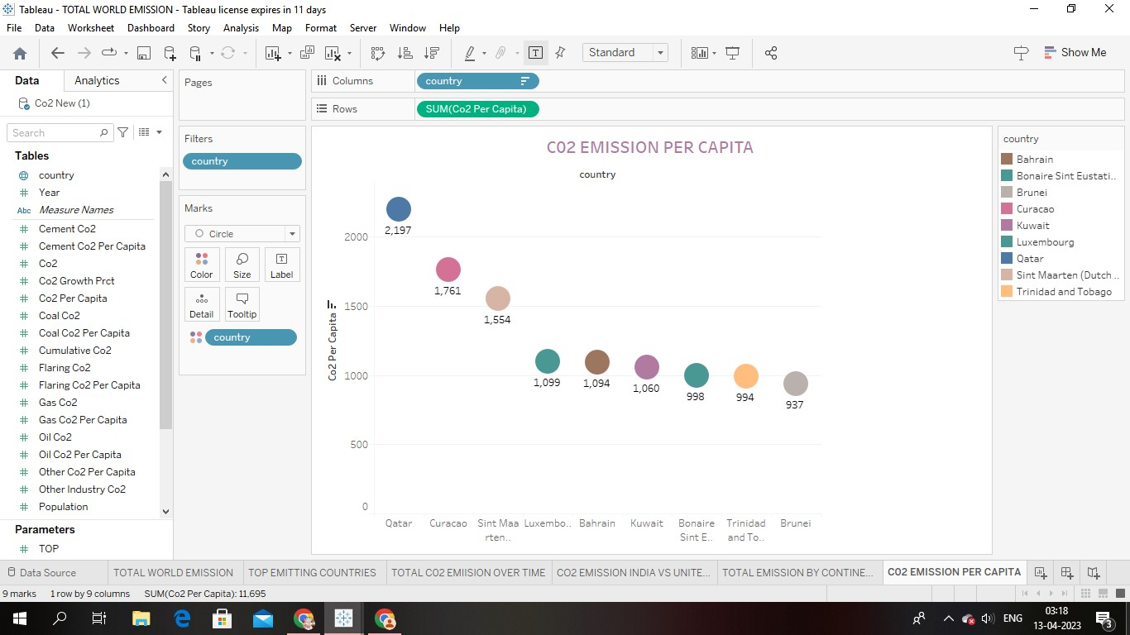

This circle plotted graph exhibits the emission of co2 per capita.

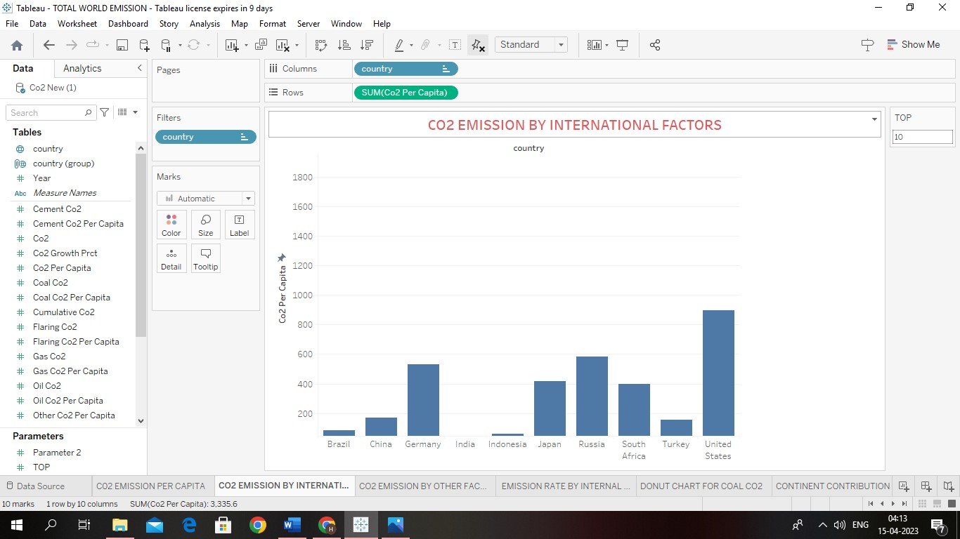

This bar diagram represents the co2 emission by international factors.

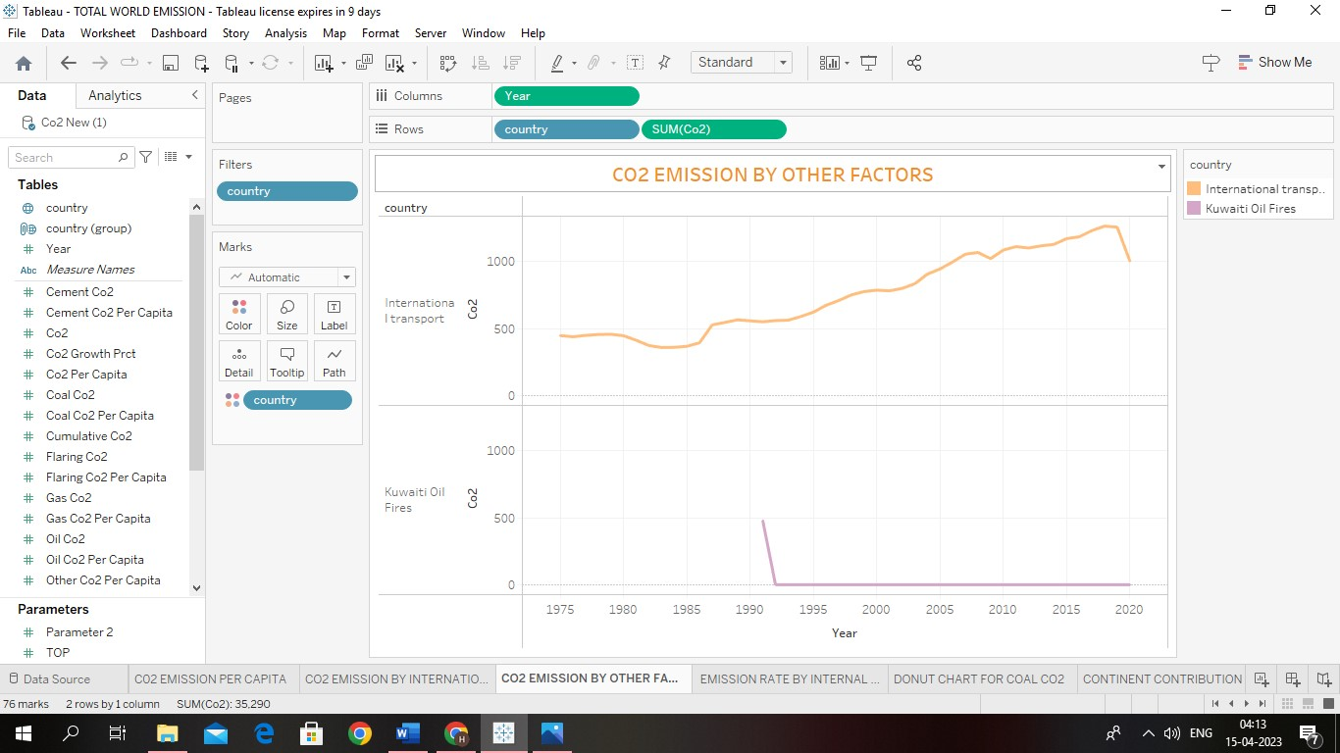

This graph represents the co2 emission by other factors.

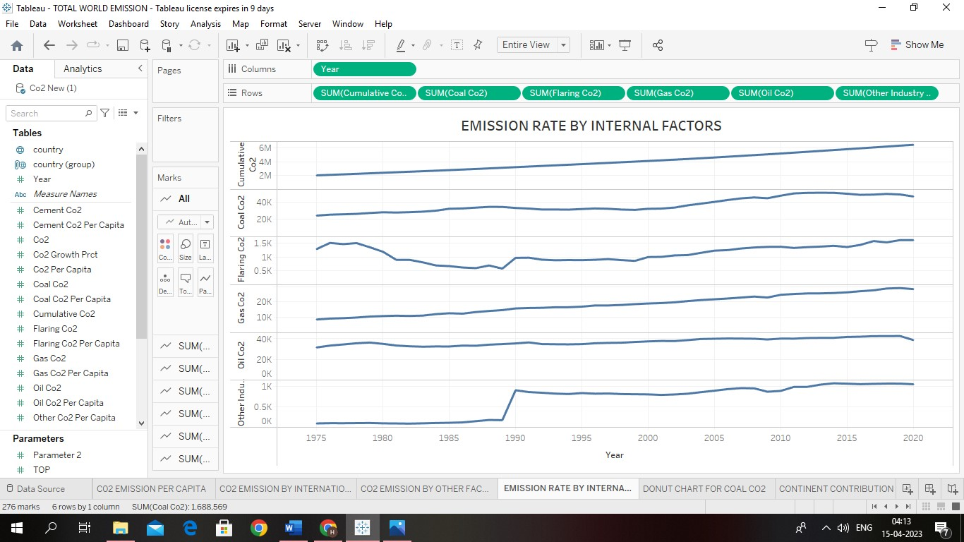

This graph indicates that emission rate by internal factors.

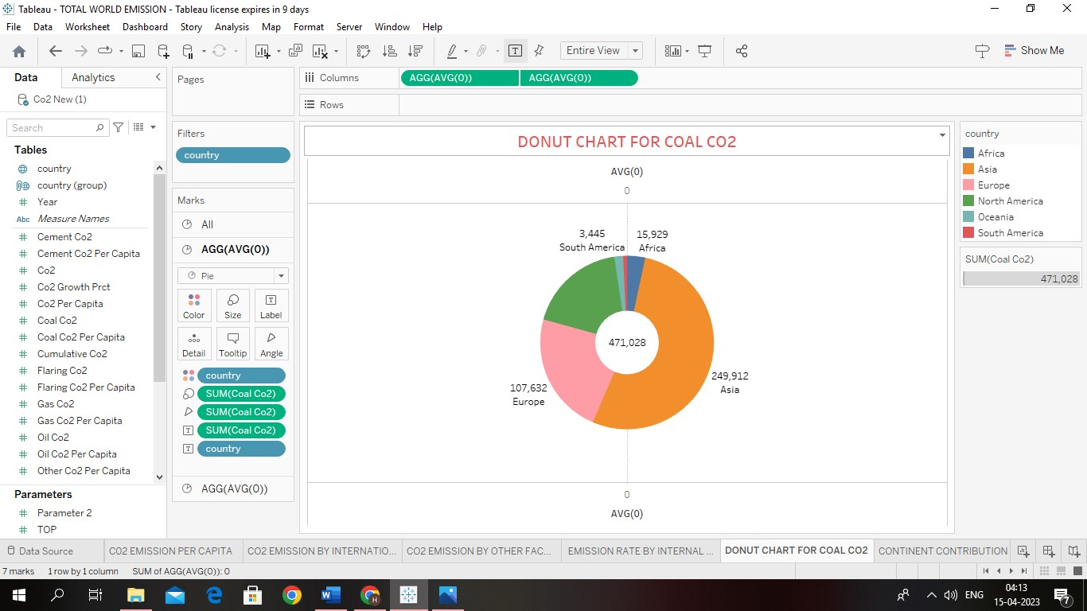

This donut diagram depicts the amount of coal co2 emitted in the countries.



This bar diagram depicts the emission of co2 by international factors.

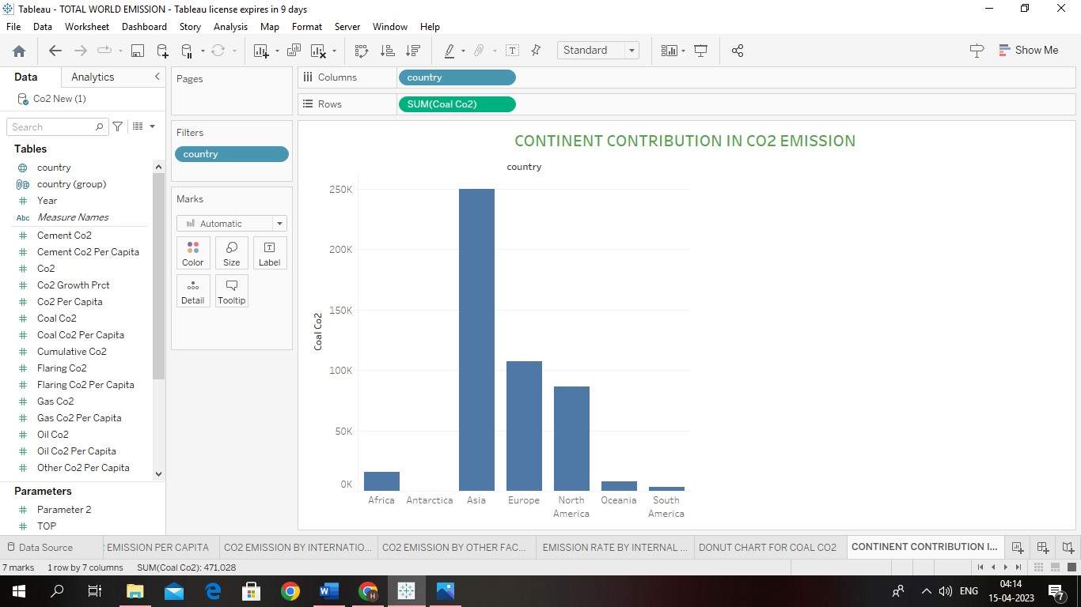

This bar diagram depicts the emission of co2 in each continent.

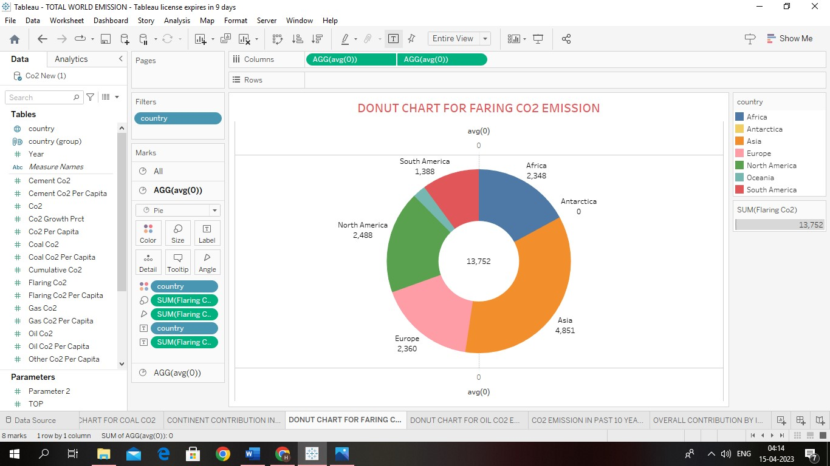

Here this donut chart depicts the emission of faring co2 emission in top countries.

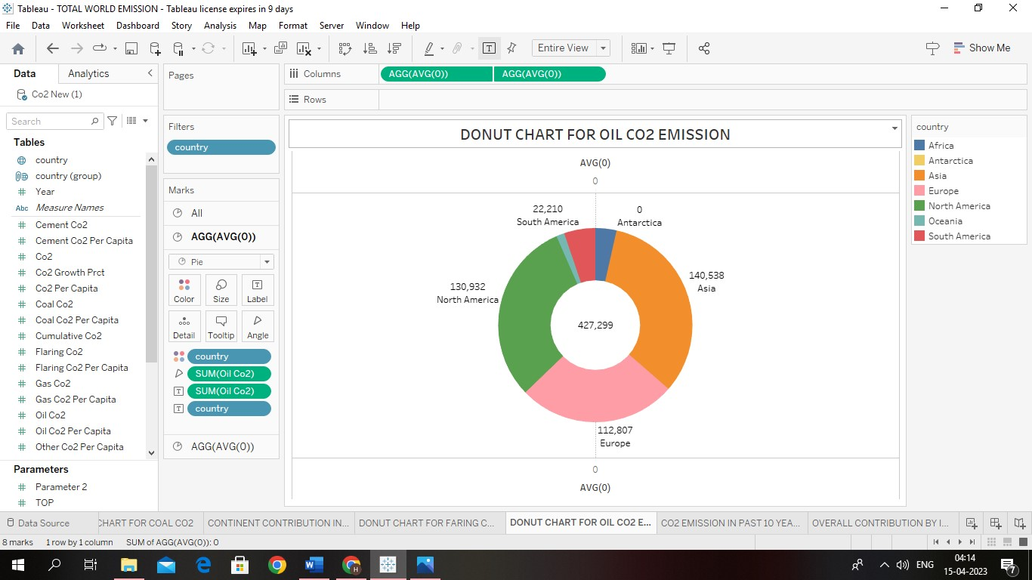

This donut chart represents the co2 emission by using the oils.

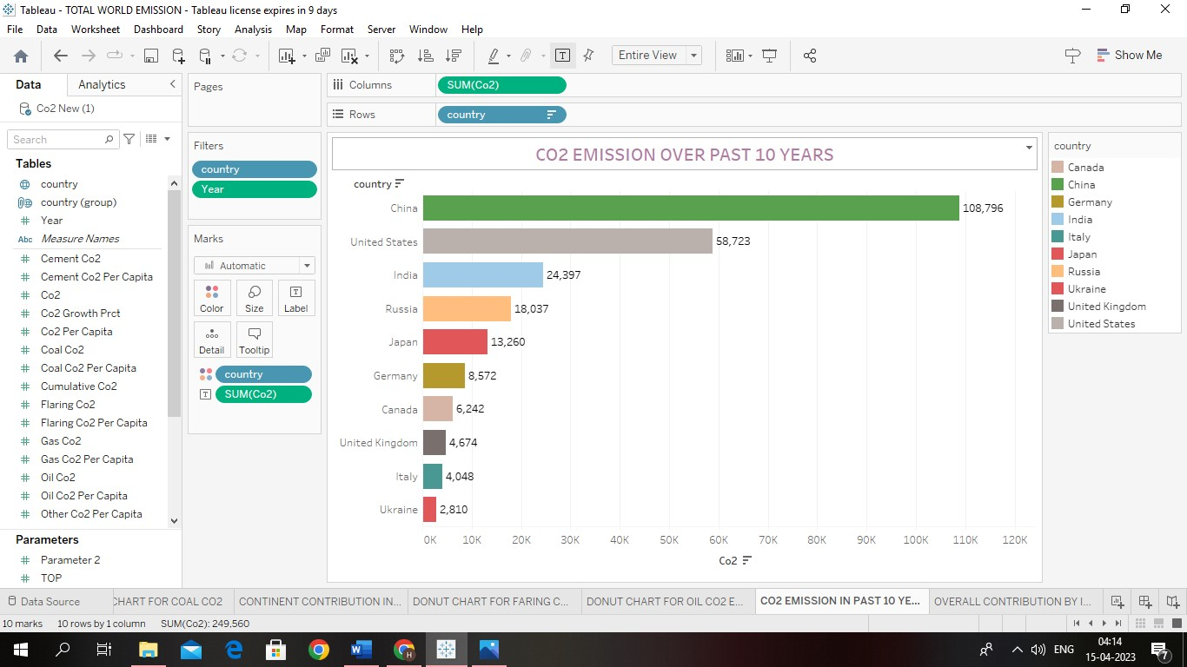

This bar graph depicts the emission of co2 in the past 10 years. The co2 is increasing rapidly from 2010 to 2020.

## 4. ADVANTAGE

Pure CO2 gas is chemically inert transparent, colourless, and odourless on a cold winner day, chilled, air, often condenses the water vapour of human breath – of which 4 to 5 percent is co2 into visible fog.

Such fog, however, is not Co2 similarly water vapour often condenses into clouds of steam over fossil fuel power plates, creating the impression of smoke such steam clouds Are not co2 either ever million air molecules into day atmosphere,400 are co2.this average makes wide variation. For example without strong ventilation co2 levels in crowed indoor spaces, such as classrooms ,courtrooms, and trains commonly reach 2000 ppm- with no clinically documented lie effect to people ,this us navy strives to keep co2 levels in its submarines bellow 5000 ppm on a calm summer days co2 concentrations in a corn field can drop to 200 ppm as the growing corn consumer it’s the available Co2 at a concentration of about 150 ppm or less many plants die as Co2 starvation.

**DISADVANTAGE**

The levels of Co2 in the air and potential health problem are 400 ppm average outdoor air level.400-1000 ppm typical level found in occupied spaces with good air exchange. 1000-2000 ppm level associated with complaint of drowsiness and poor air. 2000-5000 ppm level associated with headaches sleepiness and stagnant, stage stuffy air poor concentration loss of attention, increased heart and slight nausea may also be present.

High co2 levels generally over 1000ppm indicates a potential problem a with air circulation and fresh air in a room or building. In generally high co2 level indicate the need to examine the HVAC system. High carbon dioxide levels can cause poor air quality and can even extinguish pilot fights on gas – power appliances.

### 5. APPLICATION

***Multi-Industry Uses for Carbon Dioxide (CO2):***

Carbon dioxide in solid and liquid forms is used for refrigeration and cooling. It is used for refrigeration and cooling. It is used as an inert gas in chemical process in the storage of carbon powder and in fire extinguishers metals industry. Carbon dioxide is used in the manufacture of causing moles to enhance their hands on.

Reducing greenhouse gas emission can improve air quality and save lives. Reducing global greenhouse gas emission to slow climate change could prevent according to a new study funded by NIENS.

***Metals Industry:***

Carbon dioxide is used in the manufacture of casting moulds to enhance their hardness.

***Manufacturing and Construction Uses:***

Carbon dioxide is used on a large scale as a shield gas in

MIG/MAG welding, where the gas protects the weld puddle against oxidation by the surrounding air. A mixture of argon and carbon dioxide is commonly used today to achieve a higher welding rate and reduce the need for post weld treatment.

Dry ice pellets are used to replace sandblasting when removing paint from surfaces. It aids in reducing the cost of disposal and clean-up.

***Chemicals, Pharmaceuticals and Petroleum Industry Uses:***

Large quantities are used as a raw material in the chemical process industry, especially for methanol and urea production. Carbon dioxide is used in oil wells for oil extraction and to maintain pressure within a formation. When CO2 is pumped into an oil well, it is partially dissolved into the oil, rendering it less viscous, allowing the oil to be extracted more easily from the bedrock. Considerably more oil can be extracted from through this process.

***Rubber and Plastics Industry Uses:***

Flash is removed from rubber objects by tumbling them with crushed dry ice in a rotating drum.

**Food and Beverages Uses for Carbon Dioxide:**

Liquid or solid carbon dioxide is used for quick freezing, surface freezing, chilling and refrigeration in the transport of foods. In cryogenic tunnel and spiral freezers, high pressure liquid CO2 is injected through nozzles that convert it to a mixture of CO2 gas and dry ice "snow" that covers the surface of the food product. As it sublimates (goes directly from solid to gas states) refrigeration is transferred to the product.

Carbon dioxide gas is used to carbonate soft drinks, beers and wine and to prevent fungal and bacterial growth. Liquid carbon dioxide is a good solvent for many organic compounds. It is used to de-caffeinate coffee. It is used as an inert “blanket”, as a productdispensing propellant and an extraction agent. It can also be used to displace air during canning. Supercritical CO2 extraction coupled with a fractional separation technique is used by producers of flavours and fragrances to separate and purify volatile flavour and fragrances concentrates.

Cold sterilization can be carried out with a mixture of 90% carbon dioxide and 10% ethylene oxide, the carbon dioxide has a stabilizing effect on the ethylene oxide and reduces the risk of explosion.

***Health Care Uses:***

Carbon dioxide is used as an additive to oxygen for medical use as a respiration stimulant.

**sEnvironmental Uses:**

It is used as a propellant in aerosol cans, it replaces more environmentally troublesome alternatives. By using dry ice pellets to replace sandblasting when removing paint from surfaces, problems of residue disposal are greatly reduced. It is used to neutralize alkaline water.

***Miscellaneous Uses for Carbon Dioxide (CO2):***

Liquid carbon dioxide's solvent potential has been employed in some dry-cleaning equipment as a substitute for conventional solvents. This use is still experimental - some types of soil are more effectively removed with traditional dry-cleaning equipment, and the equipment is more expensive.

Yields of plant products grown in greenhouses can increase by 20% by enriching the air inside the greenhouse with carbon dioxide. The target level for enrichment is typically a carbon dioxide concentration of 1000 PPM (parts per million) - or about two and a half times the level present in the atmosphere.

### 6. CONCLUSION

Hence it was a good learning experience to work on this project.

From this we can analyse the followings,

1. Country to country co2 emission
2. Year to year data on emission of co2
3. Co2 emission ( in million metric tons )
4. Co2 growth per capita
5. Cumulative co2
6. Several fossil fuels rate of emission
7. Top world emission
8. Top emitting countries
9. Co2 emission over time
10. Co2 emission between India and United states
11. Total emission by continents
12. Co2 emission per capita
13. Co2 emission by international factories
14. Emission rate over years
15. China vs India co2 emission due to internal factors.

These are observed with the help of the obtained Brainstorming map, Empathy map and Output graphs.

### 7. FUTURE SCOPE

In the annual energy outlook 2022 reference case, which assumes no change to current law or regulations. The US Energy Information Administration (EIA) protectory will fail to 4.5 billion metric tons in 2037, on 6% below the energy related to co2. Essentially scope land 2 are owned or controlled by a Company.